Spaghetti Bolognese
Ingredients:
1 Pound Ground Beef
1 Pound Ground Sausage
1 Onion - diced
1-14 Ounce Can Diced Tomatoes
1 Jar Rao’s Tomato Basil Spaghetti Sauce
2 Teaspoons Dried Basil
2 Teaspoons Dried Oregano
2 Bay Leaf’s
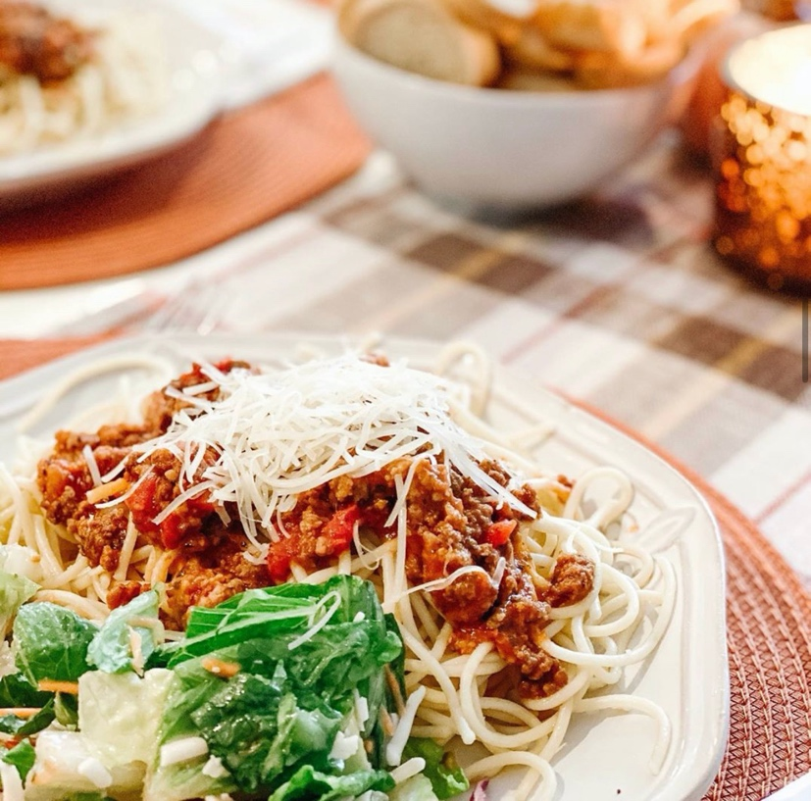

Directions:
Cook the ground beef, sausage and onion until brown and cooked through and onion is soft. Add the diced tomatoes, pasta sauce, bay leaf and salt and pepper to taste. Simmer 20 minutes. Happy Eating

*great to freeze. Place in crock pot on low for 4-6 hours when ready to eat

