Granna’s gingerbread

Ingredients:
1-1/4 cup flour
¼ cup baking powder
½ teaspoon cinnamon
½ teaspoon ground cloves
½ teaspoon ginger
½ teaspoon salt
¼ teaspoon baking soda
½ cup molasses
½ cup water
½ cup shortening
¼ cup sugar
1 egg

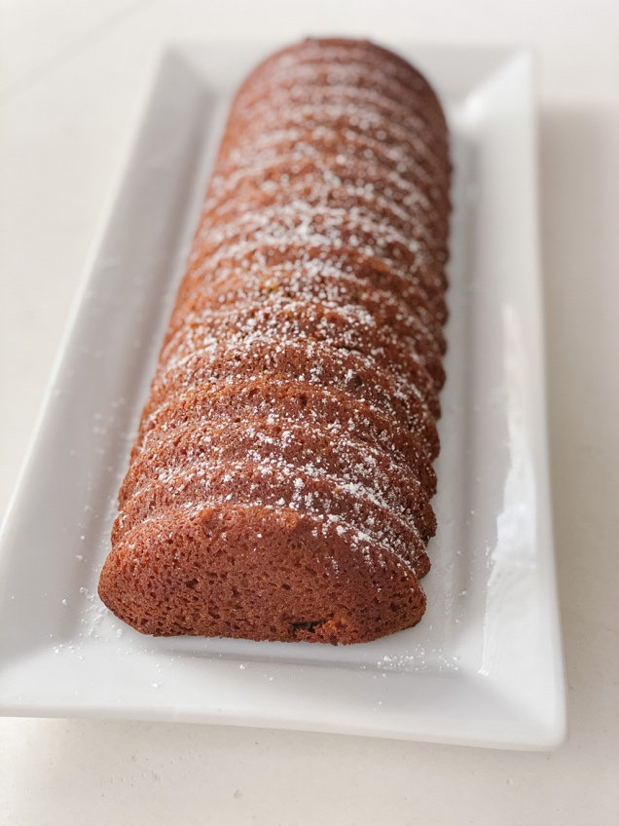

Directions:
Sift flour, baking powder, salt, baking soda and spices. Mix molasses and water until smooth. Beat shortening in large bowl on medium speed until creamy. Gradually add sugar. Beating until light and fluffy. Add egg, mix until blended. Add flour mixture alternately with molasses mixture. Bake 350° for 35 minutes.

