Granna’s Chicken Broccoli

Ingredients:
4 chicken breasts – cooked, chopped
2 broccoli crowns – cooked
2 cans cream of chicken soup
1 cup mayo
1 cup cheddar cheese
1-2 tablespoons curry powder
3 tablespoons lemon juice
½ cup milk
½ cup breadcrumbs
1 cup cheddar cheese
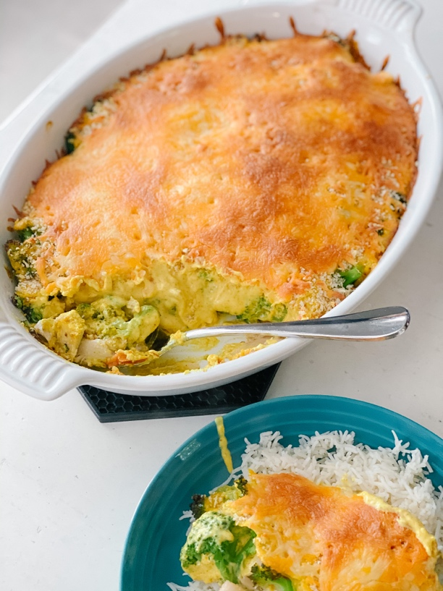

Directions:
Place cooked broccoli in a glass casserole dish cover with cooked chicken. Mix soup, mayo, ½ cup cheddar cheese, curry powder, lemon juice and milk, pour over chicken and broccoli. Sprinkle with breadcrumbs and top with remaining 1 cup cheddar cheese. Bake 350° for 30-40 minutes. Serve hot over rice.

