Thai Crunch Salad

Ingredients:
8 ounces spaghetti – broken in half, cooked, drained, rinsed cold
1 cup shredded red cabbage
1 cup shredded carrots
6-8 green onions – sliced
½ cup roasted peanuts
½ cup wonton strips
1 handful cilantro – chopped

Dressing:
¼ cup rice vinegar
2 tablespoons veggie oil
2 heaping tablespoons peanut butter – smooth
1 clove garlic – minced
Salt to taste

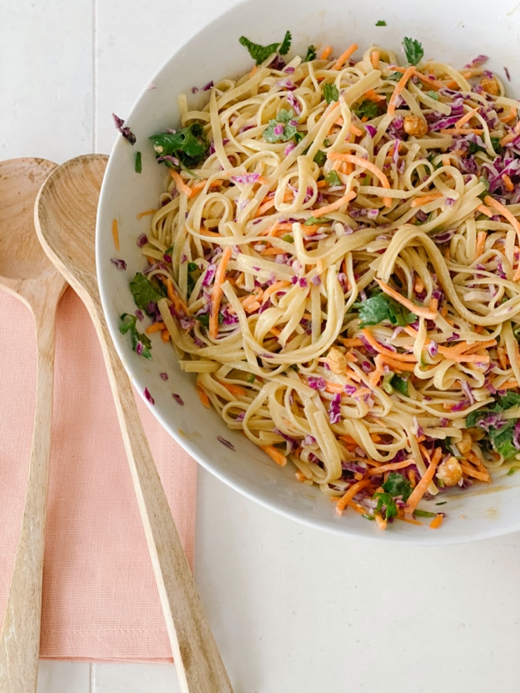
Directions:
To make the dressing put all the ingredients in a small bowl and whisk until smooth. Put the salad ingredients in a large bowl and toss with the dressing. Refrigerate until ready to serve.

