Orzo Salad

Ingredients:
1-1/2 cups orzo pasta – cooked, drained, cold
Handful of baby spinach torn
10 cherry bomb tomatoes – cut into fourths
¼ cup pine nuts
½ cup feta cheese
Bunch of basil – thinly sliced
Dressing:
2 tablespoons red wine vinegar
1 shallot – chopped
1 clove garlic – chopped
¼ cup olive oil
Bunch basil – thinly sliced
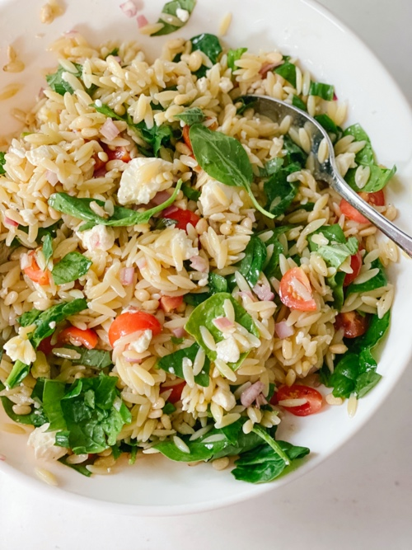

Directions:
Bring a large saucepan of salted water to a boil over high heat. Add the orzo and cook, stirring often, for about 8 minutes, or until just tender. Drain the orzo in a sieve and set aside to cool completely.
Meanwhile, to make the vinaigrette: In a medium bowl, whisk the vinegar, shallot, and garlic. Slowly drizzle in the oil while whisking to blend well. Stir in the basil and season to taste with salt and pepper. To assemble the salad and serve: In a large bowl, toss the orzo, spinach, tomatoes, nuts, and parsley with enough of the vinaigrette to coat. Fold in the cheese. Season the salad to taste with salt and pepper. Mound the salad onto the center of a large platter, sprinkle with the chives, and serve.

