Baked Beans  Ingredients:  4 slices bacon, chopped, cooked  ¼. cup pure maple syrup  ¼ cup Dijon mustard  ½ cup ketchup  2 tablespoons brown sugar  ¾ cup chicken broth  1 tablespoon Worcestershire sauce  1 tablespoon garlic – minced  3-15-ounce cans navy beans – drained, rinsed  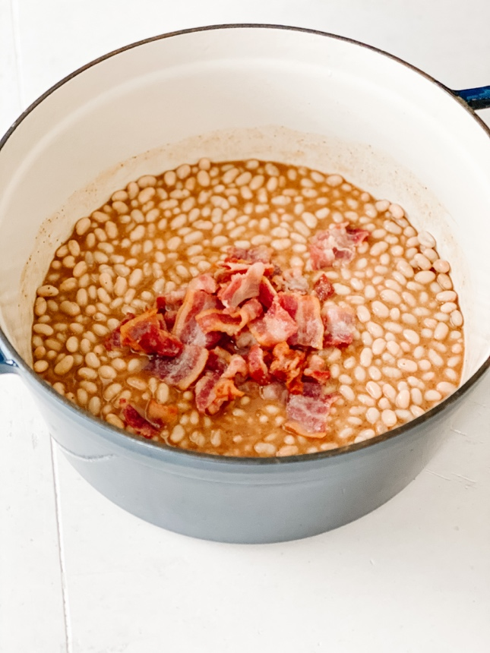  Directions:  In a medium Dutch oven combine, maple syrup, Dijon mustard, ketchup, brown sugar, chicken broth, Worcestershire sauce, garlic and ½ teaspoon salt and pepper each. Whisk to combine. Stir in the drained and rinsed navy beans. Top with cooked bacon. Bake 375° covered for 30 minutes. Remove lid and bake an additional 15 minutes. Stir, serve warm. | 