Traditional Pasta Salad

Ingredients:
1-pound macaroni pasta – cooked, drained, rinsed cold
1 4-ounce jar pimentos or jarred roasted red peppers
1 small can sliced black olives
6 sweet spicy pickles – diced

1 cup mayo
1 tablespoon red wine vinegar
3 teaspoons sugar
2 tablespoons milk
Salt and pepper
Splash of pickle juice

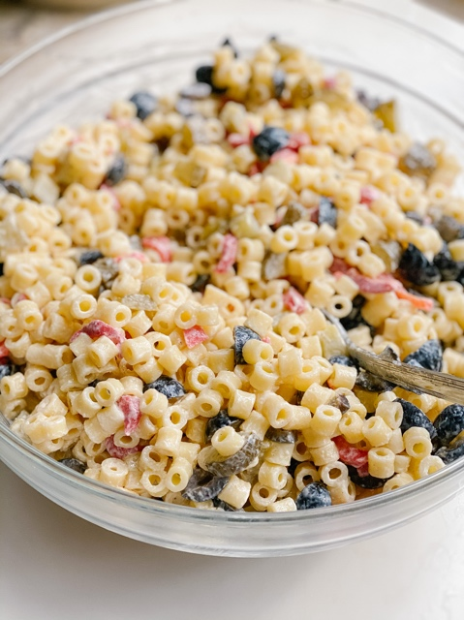

Directions:
Cook the macaroni in lightly salted water according to package directions. Drain and rinse under cold water to cool. Set aside. Mix together mayo, vinegar, sugar, salt, and pepper. Splash in enough milk to make it pourable. Splash in pickle juice for extra flavor. Taste and adjust seasonings as needed. Set aside. Place cooled macaroni in a large bowl and pour 3/4 of the dressing. Toss and add more dressing if you'd like. (Dressing will seem a little thin, but it will thicken up as salad chills.) Stir in olives, roasted red peppers (or pimentos), pickles, and green onions. Add more of any ingredient if you'd like more stuff going on! At the end, splash in a little more pickle juice and stir. Chill for at least 2 hours before serving. Sprinkle with sliced green onion to serve!

