Strawberry Summer salad

Ingredients:
3 chicken breasts – cooked, cooled, diced
1-pound penne pasta – cooked, drained, cold
1-quart fresh strawberries – chopped
1 bag baby spinach
½ cup dried cranberries – optional
½ cup cashews or sliced almonds
½ cup feta

Dressing:
½ cup veggie oil
¼ cup white balsamic vinegar
1 lemon – juiced
1 teaspoon Dijon mustard
¼ cup sugar
Whisk all together

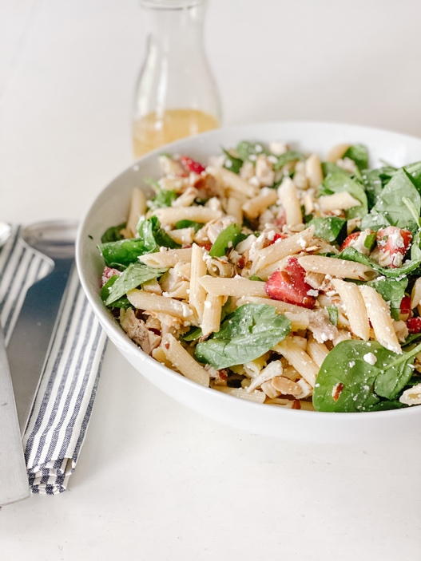
Place salad ingredients in bowl toss with about 2 tablespoons dressing. Keep in fridge until ready to serve. Take out of fridge and toss with the dressing. Serve with yummy bread like croissant or zucchini.

