Garlic Knots

Ingredients:
1-1/2 cups warm water
1 teaspoon yeast
½ teaspoon salt
2 tablespoon olive oil
2-1/2 cups bread flour

½ cup salted butter - melted
2 teaspoons all-purpose seasoning by McCormick
2 teaspoons garlic – finely chopped
½ cup grated parmesan cheese - to top
Combine butter, seasoning, garlic. Set aside.

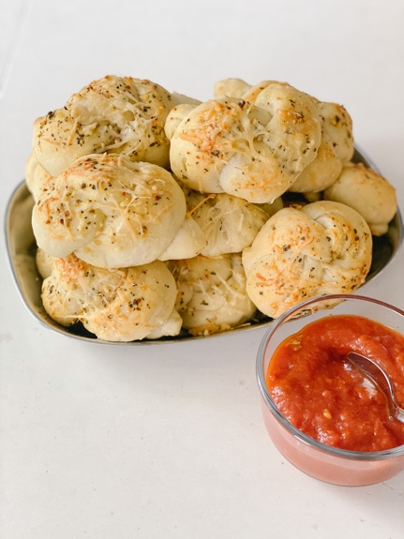
Make the dough: In a large bowl, add the water, yeast, salt and oil. Blend. Add most of the flour, reserving about ¾ cup. Blend well. I like to use my KitchenAid mixer with the dough hook for this. Slowly add the rest of the flour in until you get a dough that doesn't stick to the sides or bottom of the bowl. Add more flour, by tablespoon, until you get the right texture for the dough. You can take it out of the bowl and finish it on the counter, kneading it to get the right feel. You will know the dough is done when it is not so sticky that it comes off on your hands but when it still feels slightly moist, like Playdough. Put it in a clean bowl that has been sprayed with a little cooking spray or a teaspoon of olive oil. Cover tightly with plastic wrap and let rise for an hour and a half. If you are making the dough the day before, just pop it in the fridge at this point. Once the dough has risen, cut with a bench cutter into about 12-14 equal portions. Roll dough into a long strip and tie a knot. Place onto lined baking sheet. Brush on the melted butter mixture and top with parmesan cheese. Bake 400 for about 7-9 minutes. Once golden remove from oven. Let cool. Serve with marinara dipping sauce.

