Chicken Salad – THE BEST

Ingredients:
1 rotisserie chicken –
½ cup celery – finely chopped
½ cup pistachios – shelled, salted
¼ cup flat leaf parsley – chopped
2 green onions – chopped
1 cup dried cranberries
1 cup dukes’ mayonnaise
2 tablespoons honey
1 tablespoon curry powder
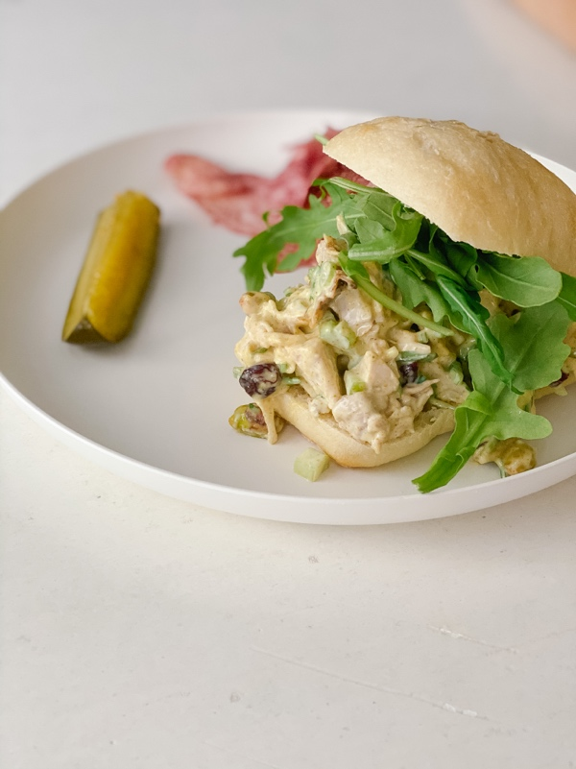

Directions:
Chop the chicken into cubes. Place in bowl and set aside. Stir in the celery, pistachios, flat leaf parsley, green onions, and dried cranberries. In a separate bowl combine, the mayonnaise, honey and curry powder. Mix to combine. Toss with the chicken mixture. Refrigerate until ready to serve or up to 2 days. Serve the chicken salad on ciabatta rolls and top with arugula.

