TRIFLE
Ingredients:
1 Package Lady Fingers
2 Large boxes cherry Jell-O
1 Small Box Vanilla Pudding
1 Cup Milk
2 Cups Whipped Cream - whipped stiff
2 cups cream - whipped with 4 tablespoons sugar and a tablespoon vanilla bean paste.
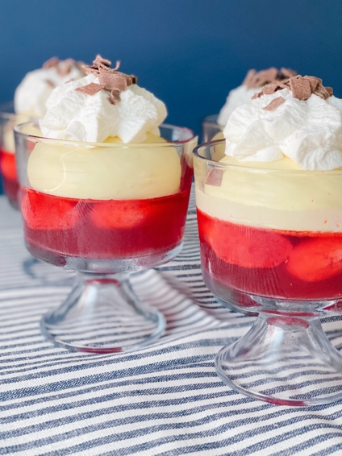

Directions:
Make both boxes Jell-O according to directions. Place lady fingers in the bottom of a trifle dish, Pour Jell-O over the top. (the lady fingers will float, this is okay!) Cover with plastic wrap. Place in fridge overnight.
The next day. Mix 1 cup milk with the small box of vanilla pudding. Whisk until thick. Place in fridge until ready to use. Beat the cream until stiff picks. (no sugar or vanilla added) Fold whipped cream into the vanilla pudding. Making sure it’s all incorporated. Layer on-top of the Jell-O, lady finger mix. Top with fresh whipped cream and chocolate shavings. Keep in fridge until ready to serve.
To add fruit. Before you put the vanilla pudding mix over the top of the Jell-O, lady fingers, you can add fresh sliced strawberries. Then add the pudding mix over the fruit. Again, finish with whipped cream and with some chocolate.

