MIMI’S SEAFOOD SALAD

Ingredients:
1-pound favorite pasta – cooked, drained, rinsed cold
1-pound bay shrimp or lobster tails
1 stalk celery – chopped
1 bunch green onion – chopped

Dressing
1-2 teaspoons old bay seasoning
Splash of pickle juice
Salt and pepper to taste
1-1/2 cups mayo

5 hard boiled eggs for the top
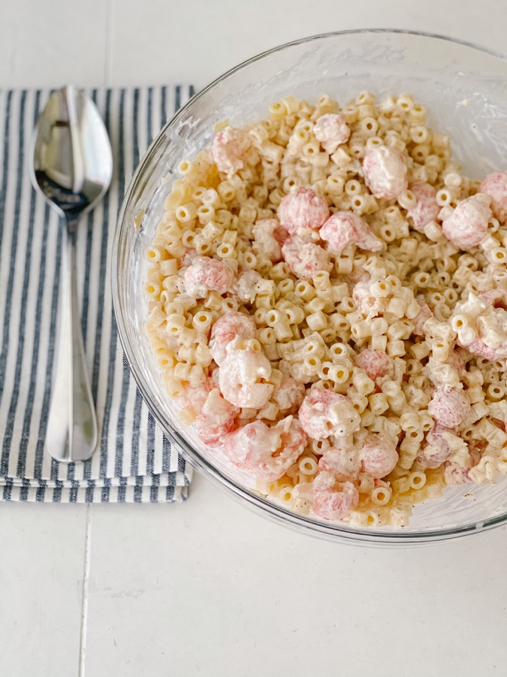

Directions:
Cook the pasta according to the package directions, drain and rinse in cold water. Combine the dressing ingredients. Set aside. Chop the celery and green onion. Place into bowl with cooked and cooled pasta. Add the seafood. Pour the dressing over the top. Toss to combine. Add the hard-boiled eggs on top.

