InstaPot Creamy Ziti

Ingredients:
2 cups chicken broth
2 cups cream
½ teaspoon salt
¼ teaspoon pepper
1-pound ziti pasta
14.28 ounce can tomato in puree
1-1/2 teaspoons dried oregano
8-10 fresh basil leaves
1 cup parmesan cheese – grated

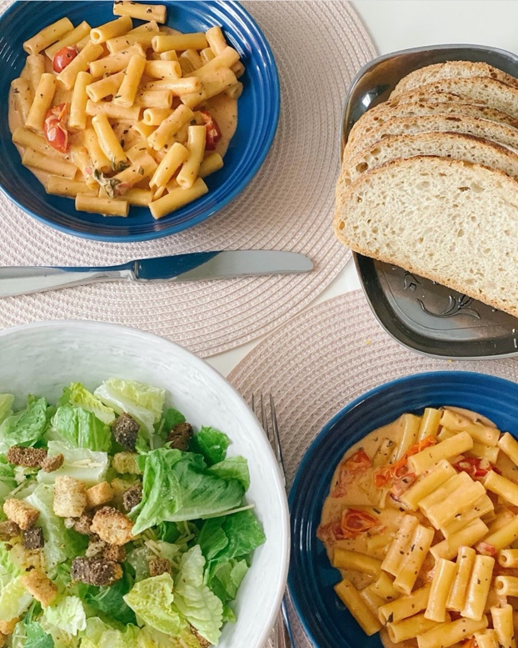

Directions:
Pour in the broth and cream and add the salt and pepper into 6-quart instapot Add the pasta, arrange into an even layer. Pour the cherry tomatoes evenly over the pasta and sprinkle the oregano and dried basil and fresh basil over the top. Don’t stir. Secure the lid of the Instant Pot, set the valve to seal, and select “manual” or “pressure cook” and dial up to 4 minutes. Let the pressure release naturally for 10 minutes and then quick release the remaining pressure. Add the Parmesan cheese and stir thoroughly. Serve hot with salad and bread.

