Street Corn Pasta Salad

Ingredients:
For the Corn:

2 cans yellow whole corn – drained
2 tablespoons butter – melted
½ teaspoon salt
¼ teaspoon black pepper
Dressing:
¼ cup mayonnaise
3 tablespoons sour cream
½ teaspoon chili powder
¼ cup lime juice
½ teaspoon salt
¼ teaspoon black pepper
Salad:
1-pound cellentani pasta – cooked, drained, rinsed cold
2 jalapenos – seeded, diced
½ cup red onion – finely diced
1 bunch cilantro – finely chopped
1 cup cotija cheese – crumbled
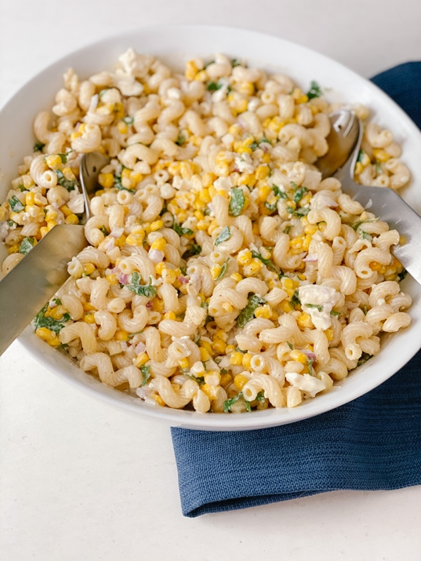

Directions:
Cook the pasta according to the package directions, drain and rinse cold. Ser aside. Mix together mayonnaise, sour cream, chili powder, lime juice, salt and pepper in a small bowl. Set aside. Drain the corn, place into medium bowl. Pour over the melted butter, salt pepper. Toss to combine. Add the cold pasta, jalapenos, red onion, cilantro and cotija cheese. Toss with the dressing. Serve cold.

