Sloppy JOES
Ingredients:
1 onion - diced
1 green bell pepper - diced
1 tablespoon olive oil
2 pounds ground beef
1-1/2 cups ketchup
2 teaspoons chili powder
1 teaspoon mustard powder
2 tablespoons brown sugar
1 tablespoon Worcestershire sauce
5-6 dashes Tabasco sauce

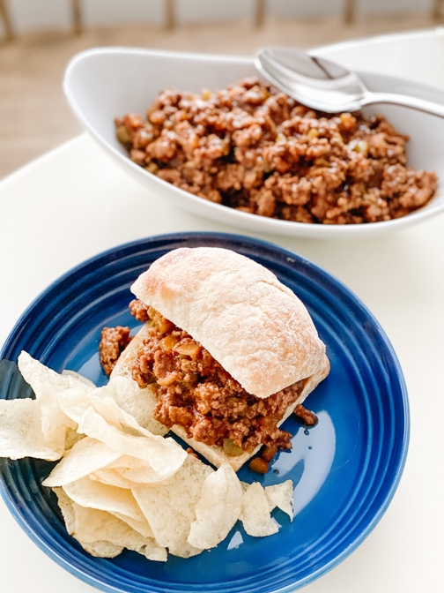
In a medium saucepan over medium heat, sauté the pepper and onion until translucent in the olive oil. Add the ground beef and cook until no longer pink. Add the remaining ingredients and simmer for about 15 minutes. Serve hot on your favorite rolls with chips or slaw.
If you are lucky enough to have leftovers, this recipe is amazing over spaghetti.

