Lemon Loaf

Ingredients:
2 peeled zest of lemons
1 cup sugar
2 sticks butter – room temp
3 eggs
1-3/4 cups cake flour
2 teaspoons baking powder
½ cup buttermilk
Glaze:
1 lemon juiced
1-1/2 cups powder sugar
Combine until smooth
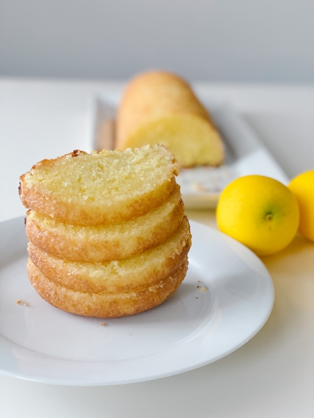
Directions:
Spray your loaf pan with nonstick spray. Set aside. Remove the peel from the lemon. Put the sugar and lemon pealing’s in a food processor and process until the peels are completely incorporated into the sugar. Put the lemon sugar and butter into a glass bowl and cream with the hand mixer until light and fluffy. Beat in each of the eggs, one by one, making sure each egg is fully incorporated before adding the next one. Continue beating for another 2-3 minutes. Whisk together the flour, baking powder, and add to the mixer, alternately with the buttermilk, beginning and ending with dry ingredients. Finish mixing by hand, to make sure everything is thoroughly mixed, but don't over mix.
Turn the batter into the prepared pan, spread out evenly, and bake 350 degrees on the center rack for 40 minutes, or until fully risen and a toothpick inserted near the center comes out without wet batter clinging to it (moist crumbs are fine.)
Let the bread cool in the pan for 10 minutes, then remove onto cooling rack. Once cooled, glazed.

