Lemon Chicken

Ingredients:
2 large chicken breasts
1 egg
Pinch salt and pepper
1 tablespoons veggie oil
½ cup corn starch
¼ flour
1 lemon juiced
¼ cup lemon sugar
2/3 cup water
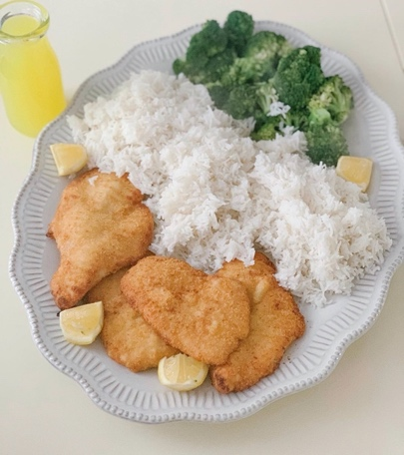

Directions:
Slice the chicken breasts in half butterflied into two thinner pieces each. Add the egg, salt, pepper and oil into a bowl and whisk together. In a separate bowl, add corn starch and flour and mix well. In a large skillet heat more veggie oil to 375° Dip chicken pieces in the egg mixture, then dredge in the flour mixture. Fry the chicken for 3 to 4 minutes or until golden and crisp. Remove the chicken from the pan, then drain the oil. Add the lemon juice, sugar, water and remaining 1 tablespoon cornstarch to the pan and whisk to combine. Cook until thickened and smooth. Slice the chicken into thin strips then serve with lemon sauce and rice!

