Cinnamon Rolls 24 rolls

Ingredients:
28 grams yeast
1 cup warm water
4 eggs – beaten
1 cup oil
½ cup sugar
1-1/2 teaspoons salt
1 cup milk
9 cups flour

Filling:
1 stick butter – melted
1 cup brown sugar
2 tablespoons cinnamon
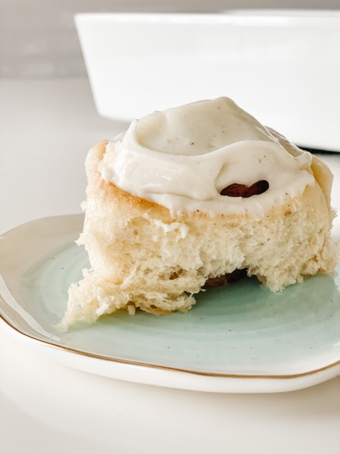
Frosting:
½ stick butter – soft
8 ounces cream cheese
3-1/2 cups powder sugar
1 teaspoon almond extract
1 tablespoon vanilla bean paste

Directions:
Add yeast and warm water to stand mixer. Let stand 5 minutes until is blooms. Add eggs, oil, sugar, salt, milk and last the flour. Mix with dough hook until the dough comes together. Remove and place in clean bowl. Let rise about 1 hour, until doubled in size. Half dough. Roll out 1 portion at a time. Place half the melted butter and half cinnamon and brown sugar on top. Roll and cut into 12 portions. Let rise an additional hour. Bake for 15-17 minutes. Cool.
To frost, combine the butter, cream cheese and using a hand mixer, mix until smooth. Add the powder sugar, vanilla bean paste, and almond extract. Remembering that you can always add more milk, but can’t take away, so a little bit at a time. Mixing again with the hand mixer, until it comes together as a smooth frosting.
