Chocolate Loaf Bread

Ingredients:
1 stick butter
½ cup semi-sweet chocolate chips
1 cup milk
½ cup cocoa powder
3 eggs
¾ cup sugar
½ cup sour cream
1 teaspoon vanilla
1 cup flour
2 teaspoons baking powder
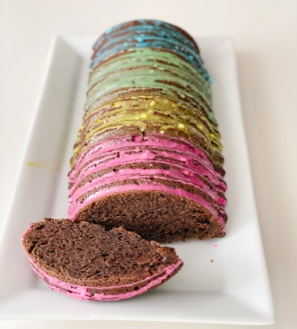

Directions:
Preheat oven to 325°F. Line a loaf pan with parchment paper and spray with non-stick spray. Set aside.
In a medium bowl combine the butter, chocolate chips, and milk. Melt in the microwave for 30 – 60 seconds or until the chocolate is melted. Add the cocoa powder and whisk until smooth.
In a large bowl whisk together the eggs and sugar until combined, until the sugar is mostly dissolved, and the eggs begin to lighten in color. Add in the sour cream, vanilla, and chocolate mixture. Sprinkle flour, salt, and baking powder over the top and whisk gently, just until no dry flour remains.
Pour batter into prepared loaf pan and bake on the middle rack for 40-50 minutes, or until a cake tester inserted into the thickest part comes out with only a few moist crumbs attached, but no uncooked batter.
Let cool 10 minutes. Remove from pan, let cool completely. To frost, I simply mixed powder sugar with a drop of milk, and food coloring, whisk to combine and then spoon over the top.

