Soft Oatmeal Cookies with Biscoff Glaze

Ingredients:
2 cups oats
1 teaspoon baking powder
½ teaspoon cinnamon
1-1/2 cups flour
½ cup butter – soft
2 tablespoons veggie oil
1 cup light brown sugar
1 egg
6 tablespoons milk
2 teaspoons vanilla

¼ cup biscoff spread
¼ cup milk
1-1/2 cups powder sugar
2 teaspoons light corn syrup
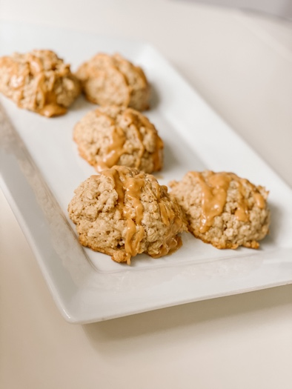

Directions:
Whisk together oats, baking powder, cinnamon, and flour. Set aside. In a large bowl, cream together the butter, oil and sugar. Add the egg, beating until fluffy. Beat in the milk and vanilla. Add in the flour mixture in three additions, beat on low just until incorporated. Let the dough rest for 30 minutes. Preheat oven to 350. Line cookie sheet with slip mat. Use 2-1/2-inch cookie scoop and place the dough onto the prepared sheet. Bake 350 degrees for 14-16 minutes. Until JUST golden.
To make the glaze. Combine everything into a medium bowl and whisk until you have a smooth frosting. Using a spoon, spoon over the top of the cooled cookies.

