Basil Couscous Salad
Ingredients:
1 Box Pearl Couscous - cooked according to package
1 Small Bag Spring Mix
1/2 Cup Cashews
1/2 Cup Strawberries - sliced
1/2 Cup Asiago Cheese - shredded
1-1/2 Cups - Cooked Breaded Chicken (optional) – diced
1/2 Cup Craisins

Directions:
Cook the couscous according to the package. *Drain. (you can stir in parmesan cheese and a DASH of milk here) Place in bowl, cover and refrigerate for 4 hours or overnight. Place the spring mix into a medium to large bowl. Sprinkle the couscous on top. Follow with cheese, strawberries, chicken (if using), nuts and craisins.
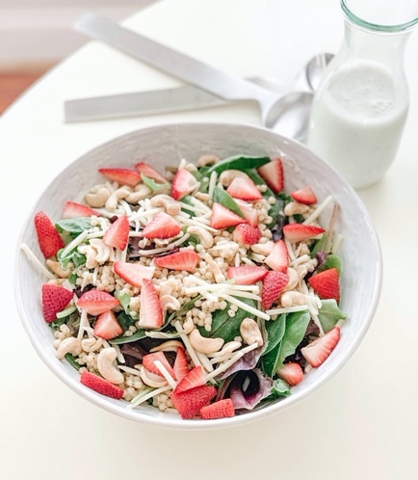
Dressing:
1 Cup Mayonnaise
2 Tablespoons Red Wine Vinegar
1/2 Cup Buttermilk
1 Cup Basil - chopped
Salt & Pepper to taste
Place all ingredients into a Pyrex measuring up. Blend with a handheld blender until just combined and the basil it’s speckled. Toss dressing with salad to liking.

Adapted from Bountiful Kitchen

