Baja Marinated Chicken & Dressing

Ingredients:
1-pound chicken tenders or breasts
1 bunch cilantro
4 garlic cloves – peeled
1 lime – juiced
2 tablespoons olive oil
1 teaspoon chili powder
1 teaspoon cumin
1 teaspoon onion powder
½ teaspoon paprika
½ teaspoon salt
½ teaspoon pepper
½ teaspoon sugar
Dressing:
¼ cup ketchup
¼ cup red wine vinegar
1 tablespoon sugar
½ cup mayonnaise
2 tablespoons reserved cilantro lime marinade
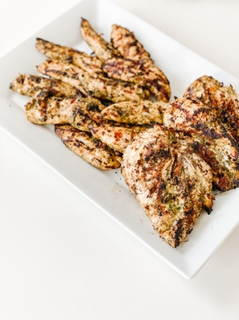

Directions:
Add all marinade ingredients to your food processor. Pulse until finely chopped, scraping down sides several times. Remove and reserve 2 tablespoons for dressing. Add the remaining marinade to a large freezer bag. Add chicken and turn to coat. Marinate in the refrigerator overnight. Remove from bag and grill on the BBQ.
Whisk together all of the Dressing ingredients in a medium bowl, including the 2-tablespoon reserved Cilantro Lime Marinade. Store in the refrigerator. Best if chilled at least 30 minutes. May keep in an airtight container up to 7 days.

