Asiago Pasta Salad

Ingredients:
1-pound bow tie pasta - cooked, drained, cold
¾ cups mayo
1 tablespoon red wine vinegar
½ teaspoon garlic powder
½ teaspoon ground pepper
4-ounce jar pimentos – drained
1 -3.8 ounce can slice olives - drained
5 ounces Asiago cheese
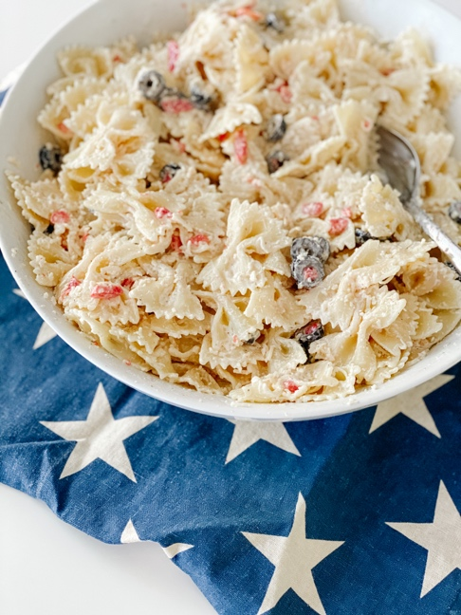

Directions:
Cook the pasta until al dente. While the pasta is cooking, combine the mayonnaise, red wine vinegar, garlic powder, ground pepper. Whisk to combine. Drain and rinse in cold water. Let it drain well. Toss the pasta in half the mayonnaise, cover and chill for about an hour. Remove from fridge and toss the rest of the ingredients and remaining dressing. Chill until ready to serve.

