Mini Chocolate Chip Cookies
Ingredients:
1 cup unsalted butter, room temperature
2/3 cup granulated sugar
3/4 cup brown sugar
2 eggs
2 teaspoons vanilla
2 1/4 cup all-purpose flour
2 teaspoons baking powder
2 -10 oz. bags, miniature semisweet chocolate morsels

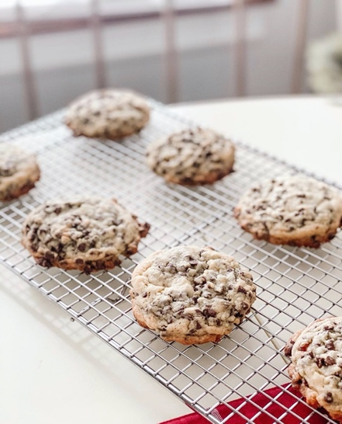

Directions:
Line a large baking sheet with parchment paper and preheat oven to 350
In a medium bowl, sift flour, baking powder together using a wire whisk and set aside.
Using a hand mixer, cream butter and both sugars until light and fluffy.
Add eggs, one at a time and mix until incorporated. Add the vanilla.
Slowly add the flour mixture and mix by hand until just combined, making sure to scrape down the sides of the bowl to incorporate completely.
Add TWO 10-ounce bags of mini semisweet morsels to the batter and mix on the lowest setting until evenly distributed.
Let dough stand at room temp for about 15 minutes. Then, using a 2.5 inch scoop, place mounds of dough on prepared baking sheet - about 5 at a time to make sure they don’t touch each other during baking.
Bake for 13-15 minutes until done and repeat with remaining dough.

