Apple Tart

Ingredients:
1 cup butter – softened
3 cups flour
2/3 cup powder sugar
½ teaspoon salt

1 cup butter – softened
1 cup sugar
1 teaspoon almond extract
4 eggs
1-1/2 cups almond flour
2 large apples – thinly sliced, enough to cover top.
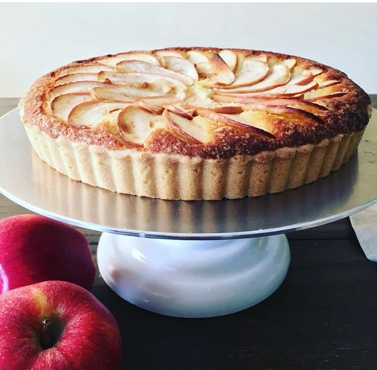

Directions:
To make the crust: Mix together the butter, flour, sugar, and salt until the dough comes together in a ball.
Grease a 9" tart pan and press the dough firmly into the base of the pan and up the sides in an even layer. You may find that you have more dough than you need; the crust should be a thin layer, approximately 1/8" thick. Don't add more dough than that or the crust will be too thick to allow the filling to set properly. Refrigerate the crust while you make the filling. To make the filling: Beat together the butter and sugar until smooth; don't overmix. Beat in the almond extract. Add the eggs one at a time, beating well after each addition. Whisk together the almond flour and all-purpose flour, then fold into the wet ingredients. Pour the filling into the chilled crust and smooth the top. Arrange the apple slices in concentric circles, overlapping each slice slightly, over the surface of the tart. Bake the tart for 40 minutes, or until the crust is golden brown. Remove the tart from the oven, and let it cool for at least 15 minutes before serving. Store any leftovers in the refrigerator, well wrapped, for several days. Freeze for longer storage.

